**Problem Statement 1:** Write a C Program to scan and count the number of characters, words, and lines in a given text file.

**Input :** Input will be a text file named - hello.txt.

**Output expected :** Count of characters, words and lines in the given text file.

**Description of problem statement :** We have to write a program to print the number of characters, words and lines in a text file which have some content in it. The file name is given as input by user.

# Algorithm :

Step 1: Start

Step 2: Open source file in read “ r ” mode.

Step 3: Initialize three variables ch=0,w=0,l=0 for character, word and line count . Step 4: Read a character from file and store it in a variable c.

Step 5: Increment count of a variable ch which will keep number of characters.

Step 5.1: Increment w for word count if current character is whitespace character i.e. if(c==' ' || c=='\t' || c=='\n' || c=='\0').

Step 5.2: Increment l for line count if current character is new line character i.e. if ((c=='\n'|| c=='\0')).

Step 5.3: Decrement ch if current character is space or newline i.e. if(c==' ' || c=='\n'

|| c=='\0').

Step 6: Repeat steps 4 and 5 till end of file has reached.

Step 7: After reaching end of file, increment w and l count by one. Step 8: Print count of characters,words and lines.

Step 9: Close the file. Step 10: Stop

## CODE:

# #include <stdio.h>

# #include <stdlib.h>

# int main() {

# FILE *f;

# char ch;

# int cha, wo, li;

# f = fopen("a.txt", "r");

# if (f == NULL) {

# printf("File not found");

# }

# cha = wo = li = 0;

# while (ch != EOF) {

# ch = fgetc(f);

# cha++;

# if (ch == ' ' || ch == '\0' || ch == '\t' || ch == '\n') {

# wo++;

# }

# if (ch == '\n' || ch == '\0') {

# li++;

# }

# }

# if (cha > 0) {

# wo++;

# li++;

# }

# printf("Characters=%d\nWords=%d\nlines=%d", cha, wo, li);

# fclose(f);

# return 0;

# }

# OUTPUT:

**File- hello.txt**

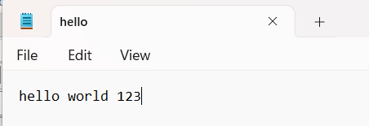

# Output :-

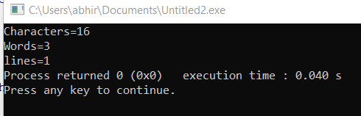

**Problem Statement 2:** Write a C program to scan and count the number of uppercase characters, lowercase characters , digits and special characters in a given text file .

**Input :** Input will be a text file named - hello.txt.

**Output expected :** Count of uppercase characters, lowercase characters ,digits and special characters in the given text file.

**Description of problem statement :** We have to write a program to print the number of uppercase characters, lowercase characters, digits and special characters in a text file which have some content in it. The file name is given as input by user.

# Algorithm :

Step 1: Start

Step 2: Open source file in read “ r ” mode.

Step 3: Initialize three variables up=0,lw=0,dg=0,sp=0 for uppercase characters, lowercase characters, digits and special characters count.

Step 4: Read a character from file and store it in a variable ch .

Step 4.1: Increment up for uppercase count if current character is in uppercase i.e. if(ch>='A ' && ch<=’Z).

Step 4.2: Increment lw for lowercase if current character is in lowercase i.e. if ((ch>='a’ && ch<='z')).

Step 4.3: Increment dg for digit if current character is a digit i.e. if(ch>='0 ' && ch<='9' ).

Step 4.4: Increment sp for special character if current character is special character

i.e. if(ch!=' ' && ch!='\n')

Step 5: Repeat step 4 until end of file has reached.

Step 7: Print count of uppercase characters, lowercase characters, digits and special characters . Step 8: Close the file.

Step 9: Stop

# CODE :

## #include <stdio.h>

## #include <stdlib.h>

## int main() {

## FILE *f;

## char ch;

## int sp, up, lo, di;

## f = fopen("hello.txt", "r");

## if (f == NULL) {

## printf("File not found");

## }

## sp = up = lo = di = 0;

## while (ch != EOF) {

## ch = fgetc(f);

## if (ch >= 'A' && ch <= 'Z') {

## up++;

## } else if (ch >= 'a' && ch <= 'z') {

## lo++;

## } else if (ch >= '0' && ch <= '9') {

## di++;

## } else {

## sp++;

## }

## }

## printf("Special Characters=%d\nUpper Case=%d\nLower Case=%d\nDigit=%d", sp,

## up, lo, di);

## fclose(f);

## return 0;

## }

## OUTPUT

**Text file - hello.txt**



